Algebra 1: Unit 9, Lesson 2

- A quadratic function has the equation, $y=a{(x+2)}^{2}-6$, and passes through the point, $(-5, 30).$ What is the value of $a$?
$$4$$

- A quadratic function with points, $(0,7),(6,-2),(12,7)$ is shown on the coordinate grid.
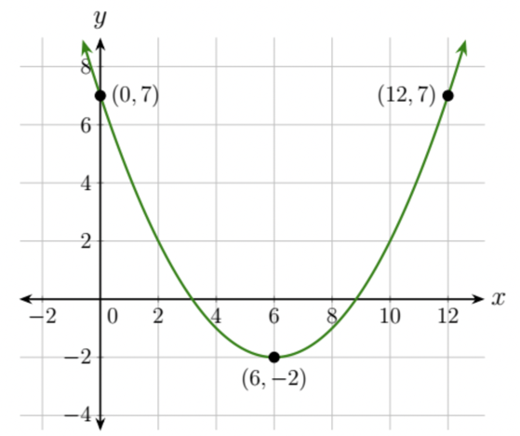
A student is writing the equation of the quadratic function in vertex form using $f(x)=a{(x-h)}^{2}+k$. What are the values of $h$ and $k$?
$h=6$ and $k=-2$

- A quadratic equation is shown on the coordinate grid. The points, $(-1,-5),(0,-8),(1,-9),(3,-5),(3.5,-2.75),$ and $(4,0),$ are labeled on the graph.
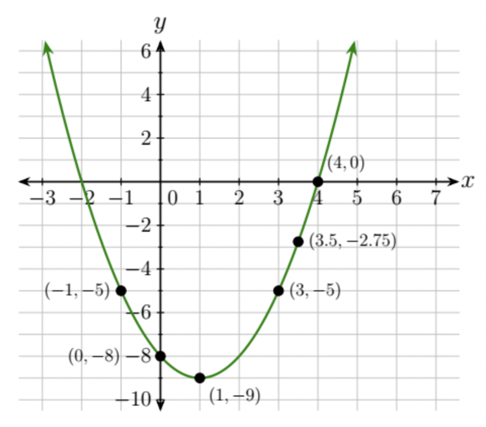
Which pair of labeled points are equidistant from the vertex?
$(-1,-5)$ and $(3,-5)$

